**→Here we will talk about Understanding the data and getting it ready for U-Net :**

**(1) Import library’s and define width, height and channels of our image :**

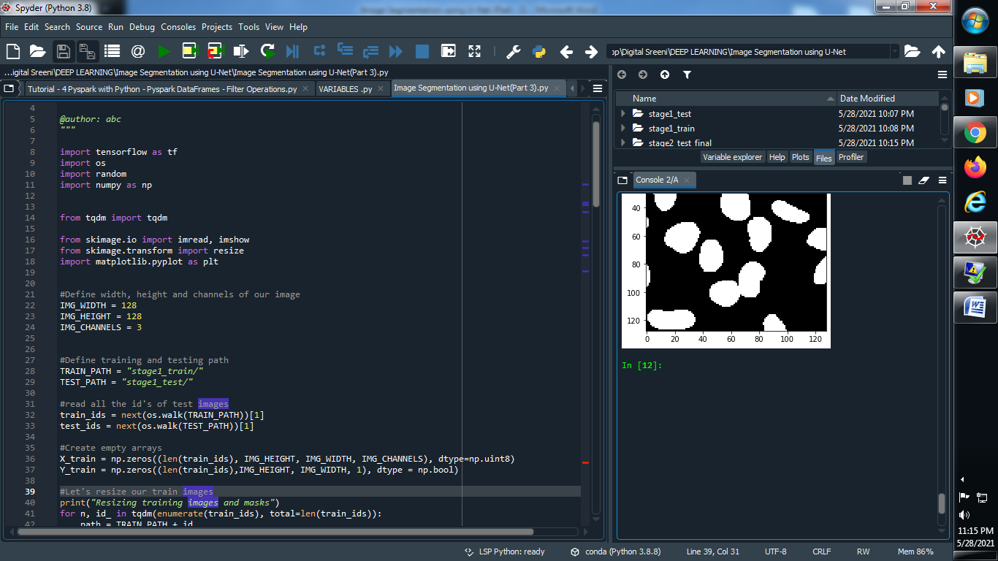

**(2) Define training and testing path :**

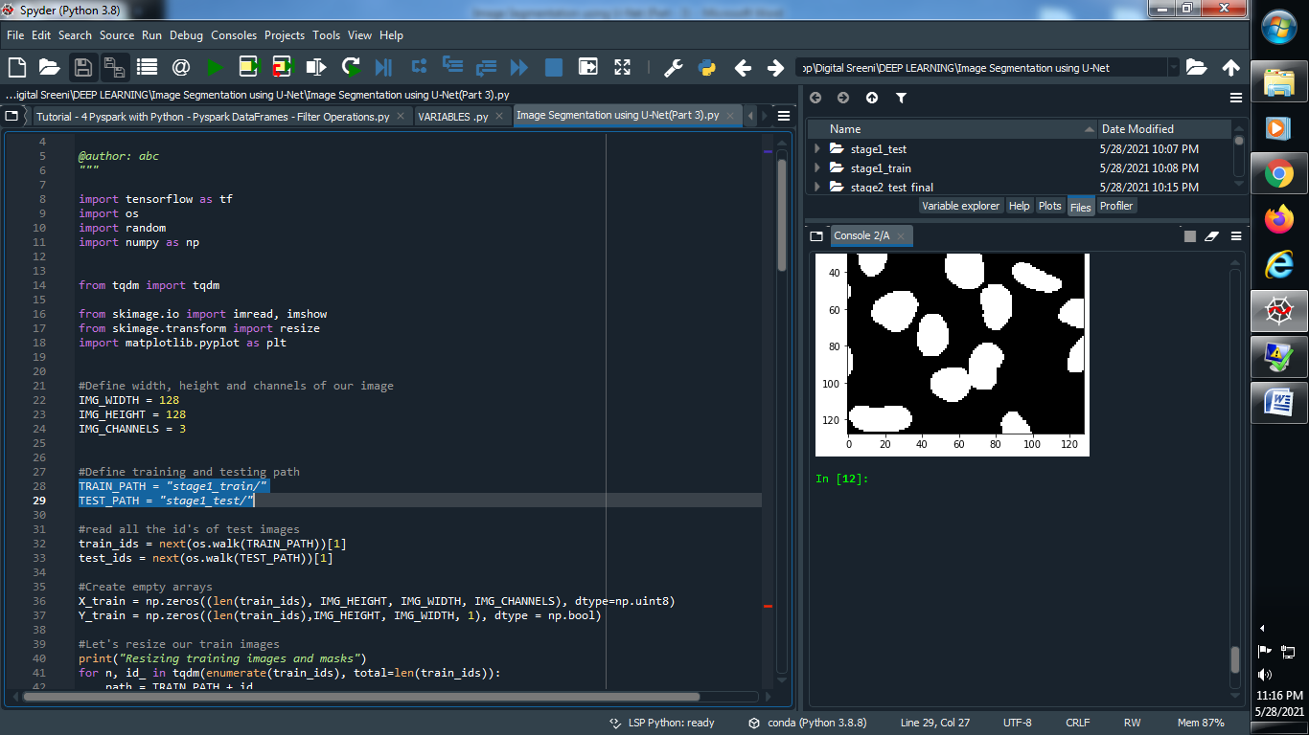

**(3) Read all the id’s of test and train images :**

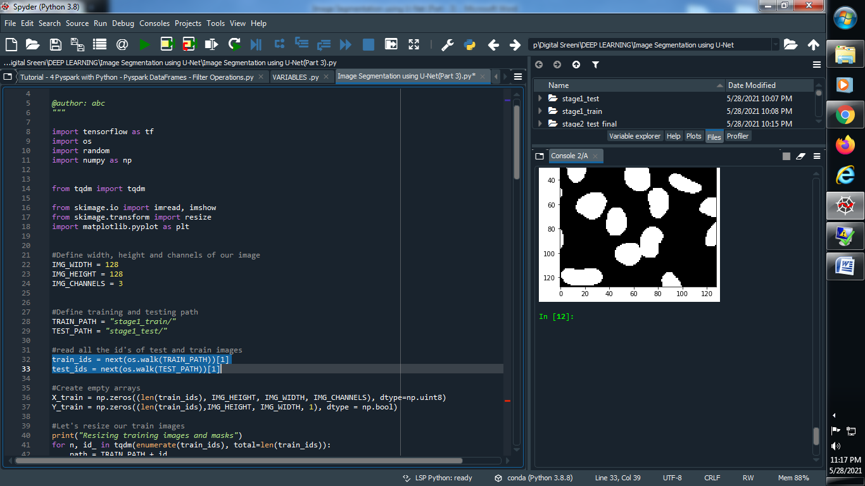

**(4) Create empty array :**

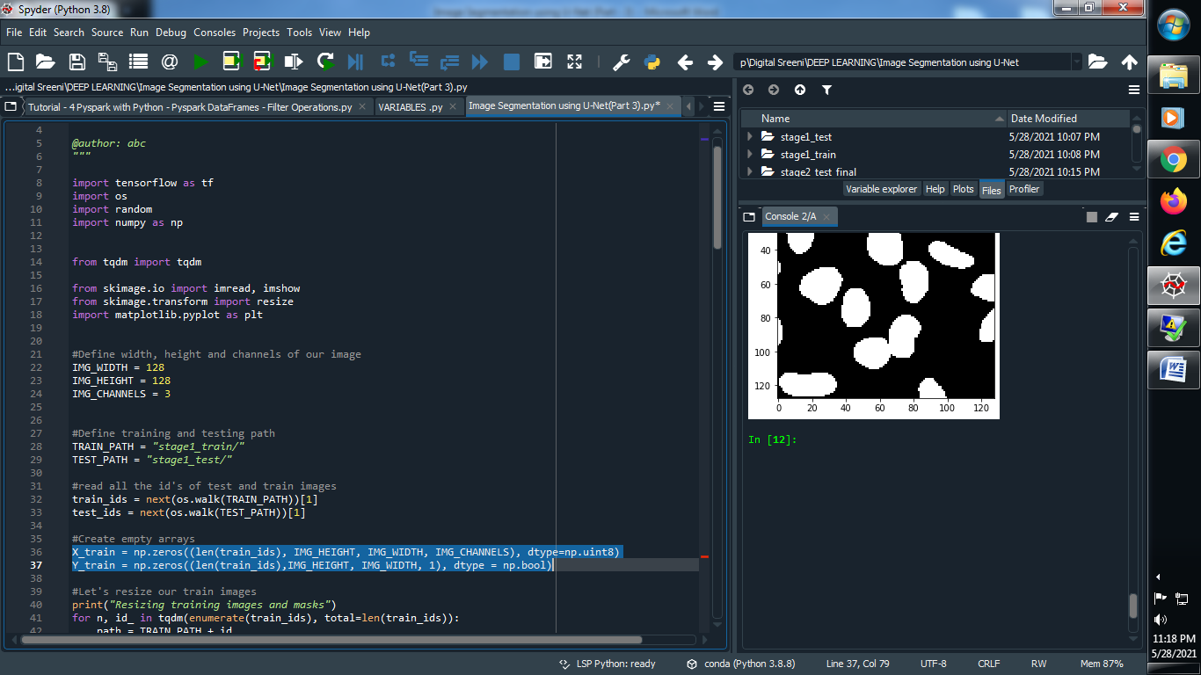

**(5) Resize our train images :**

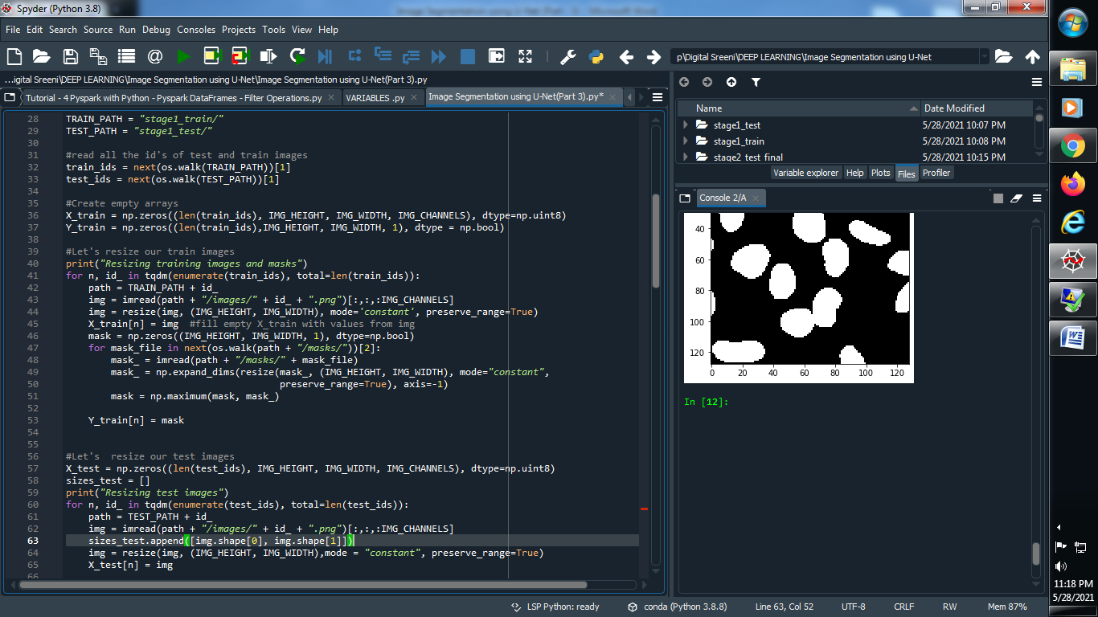

**(6) Resize out test images :**

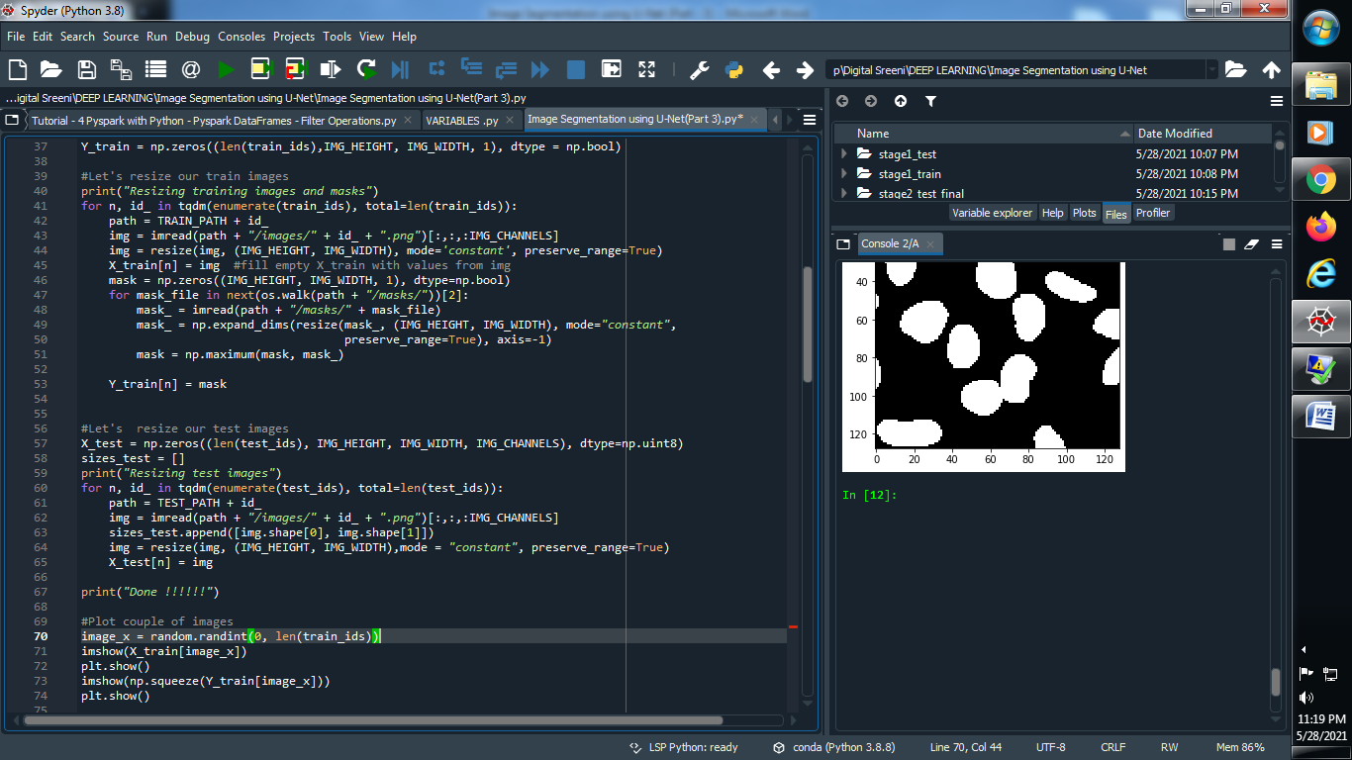

**(7) Plot some random images :**

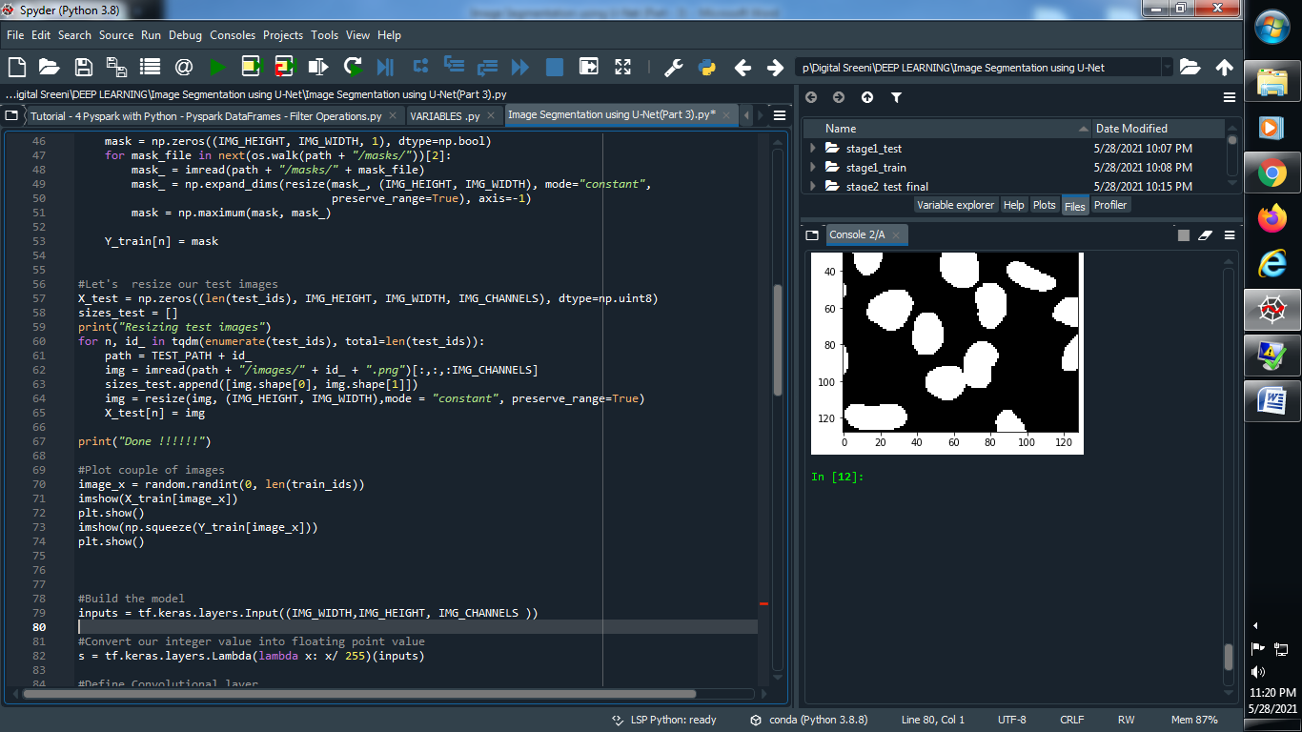

**Output :**

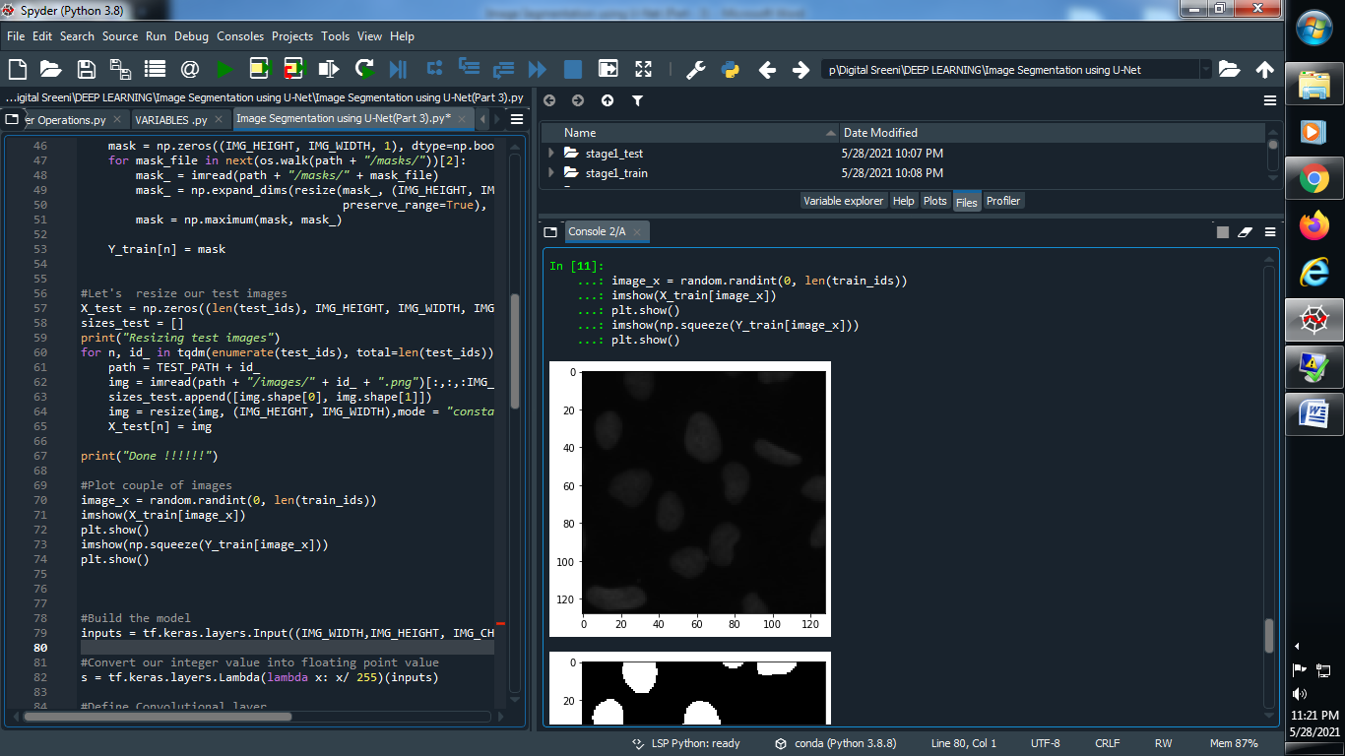

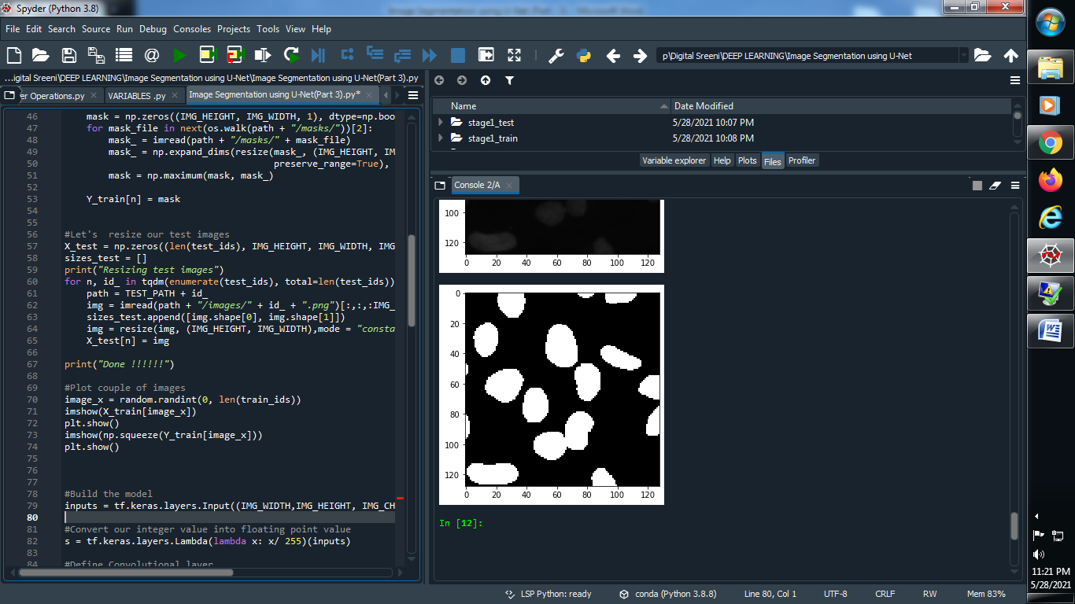

**(4) Define Convolutional layer :**

**→ Contraction path :**

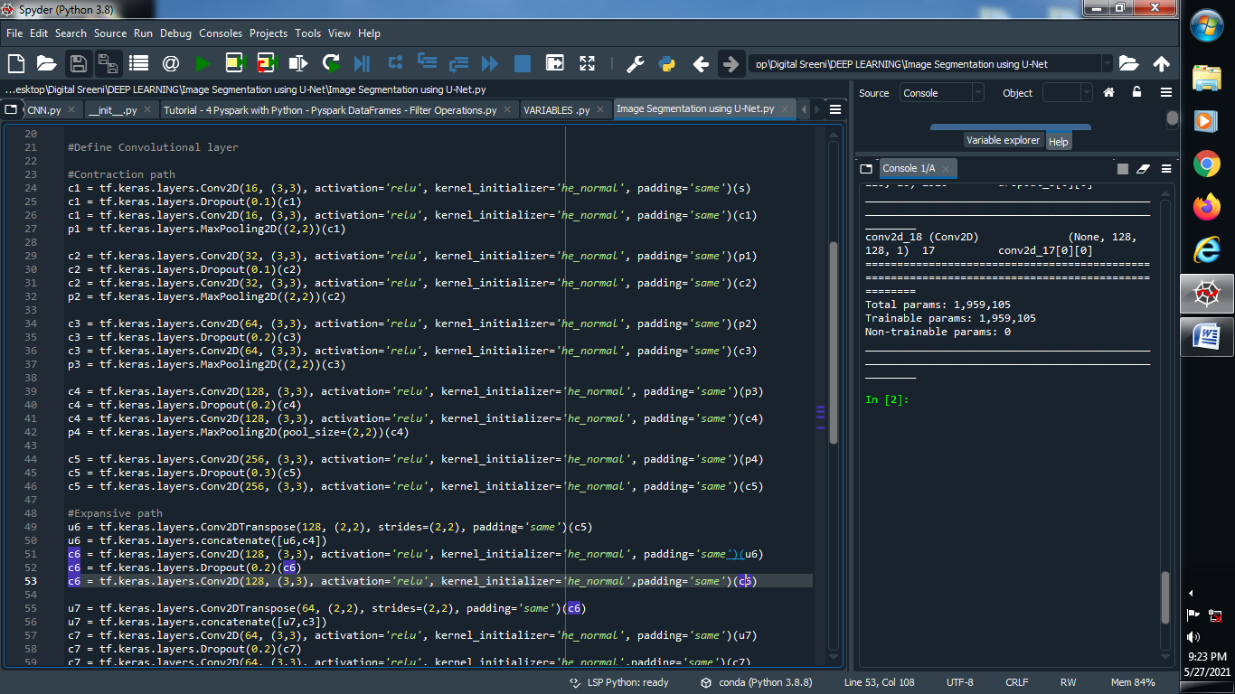

**→ Expansive path :**

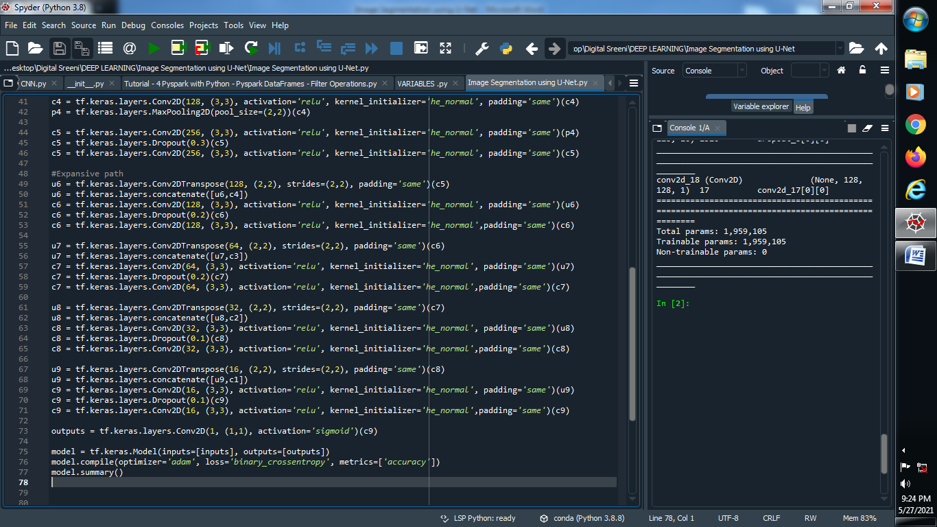

**(5) Define outputs :**

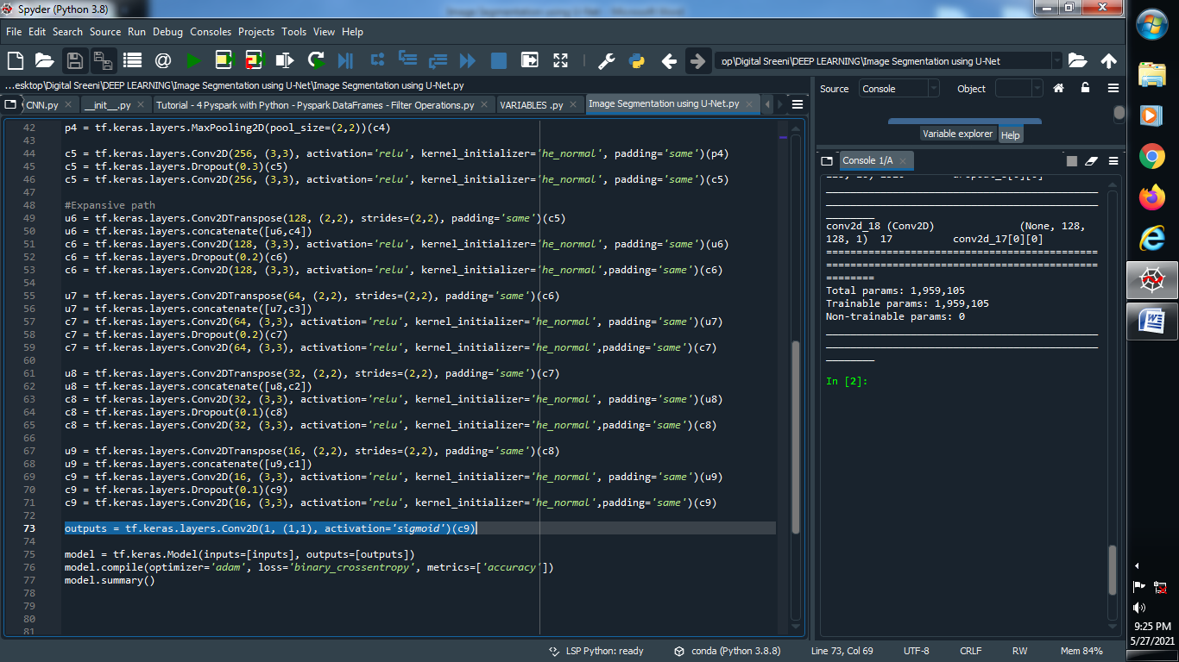

**(6) Compile the model and let’s see our output :**

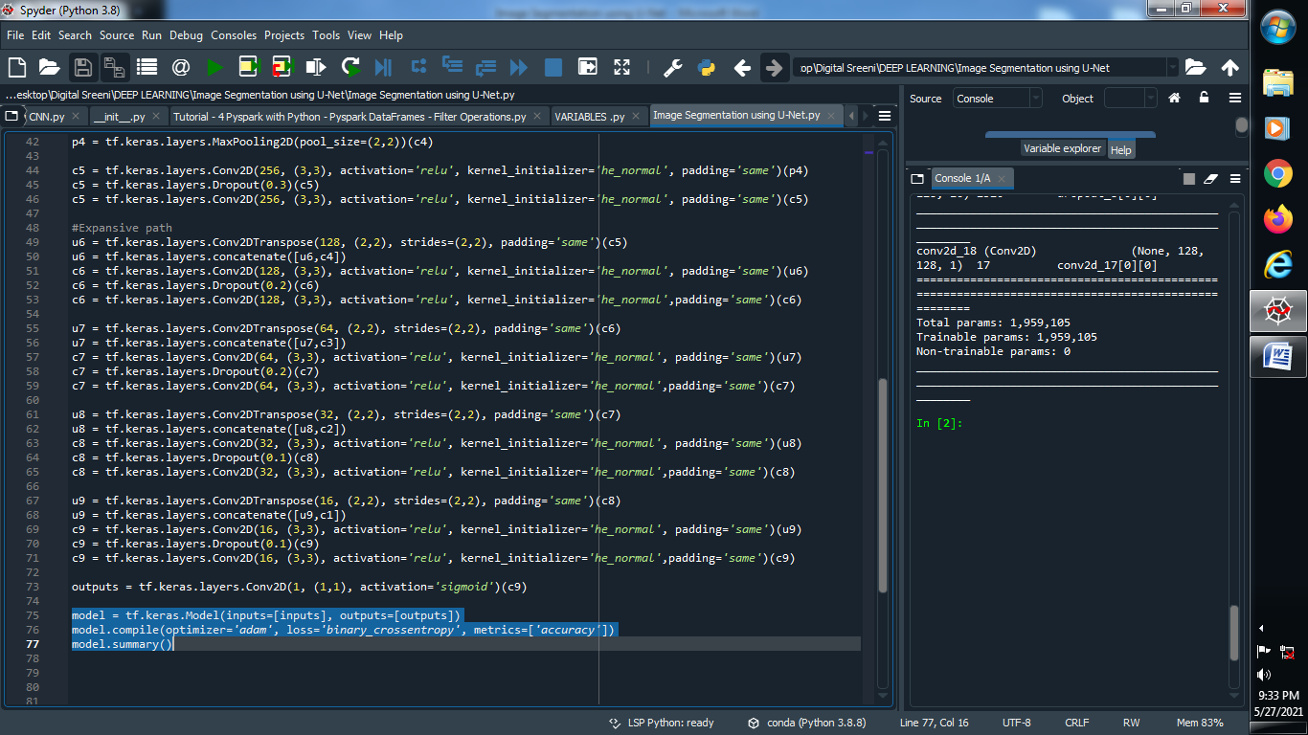

**Output :**

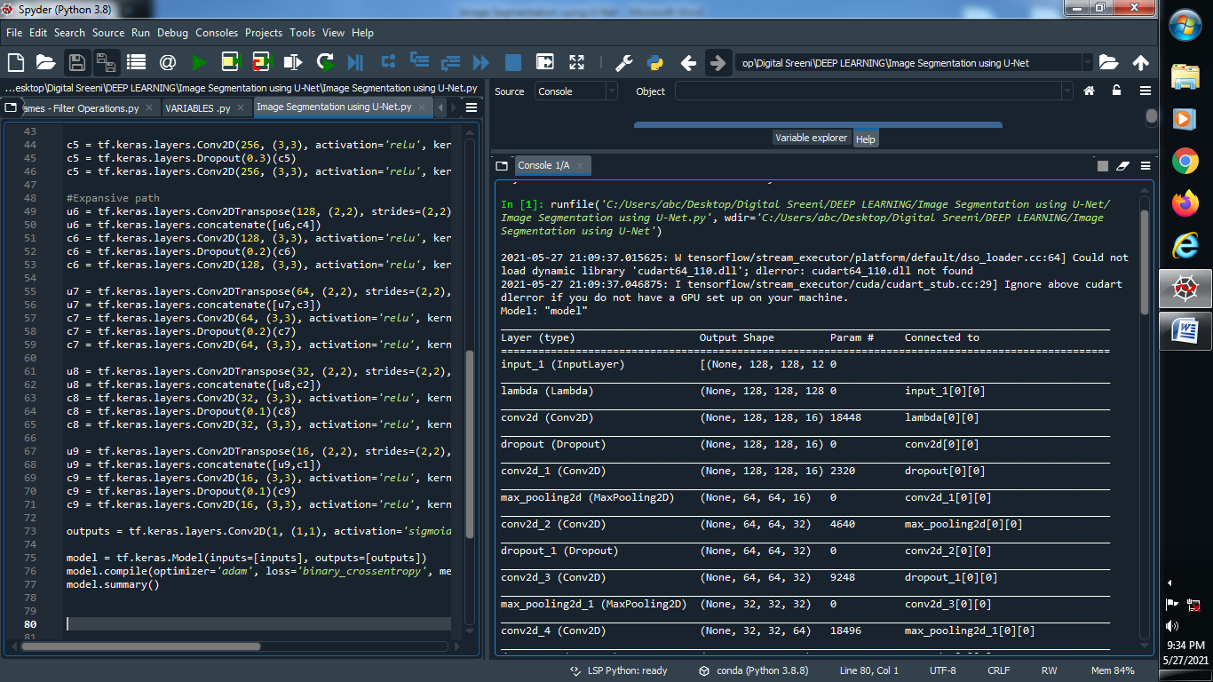

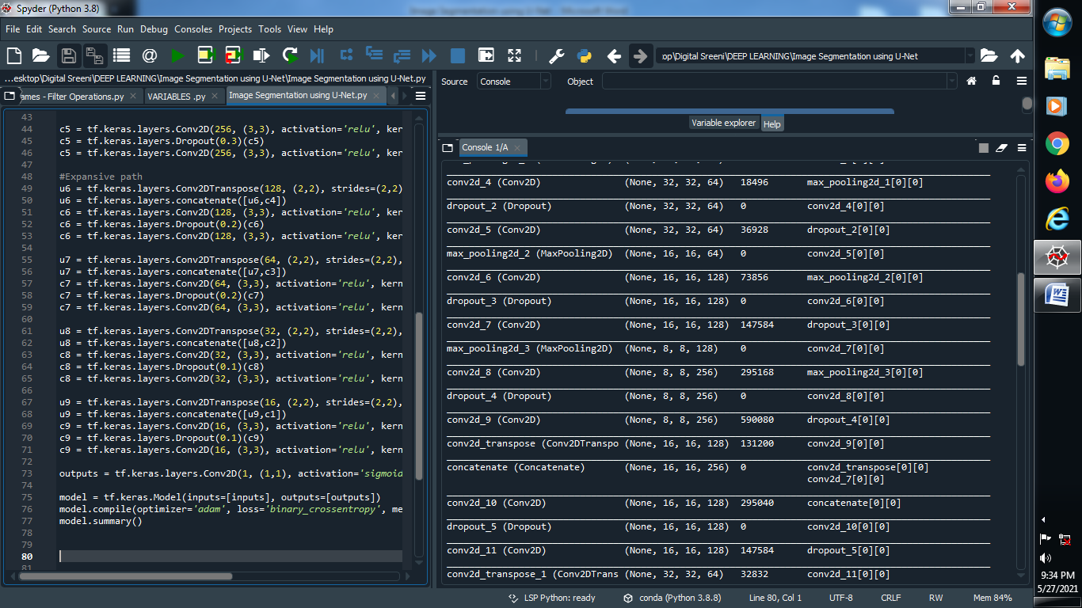

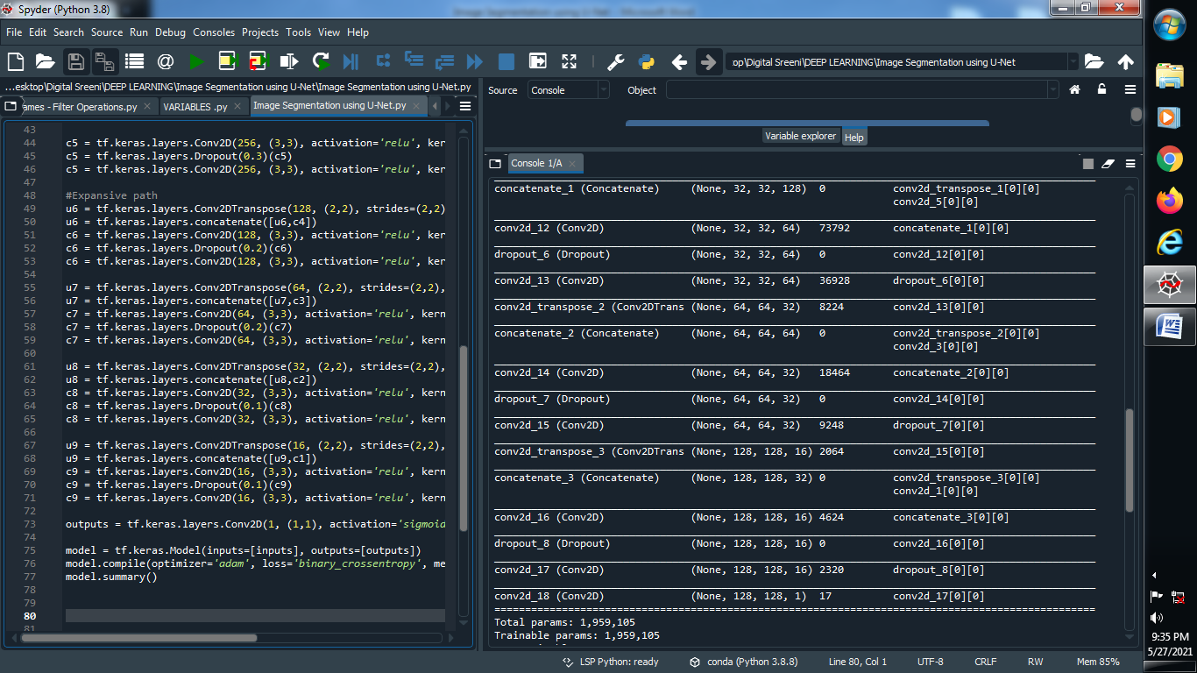

#####################################################################################

**→ Model fitting, checkpoints, early stopping and callbacks using U-Net :**

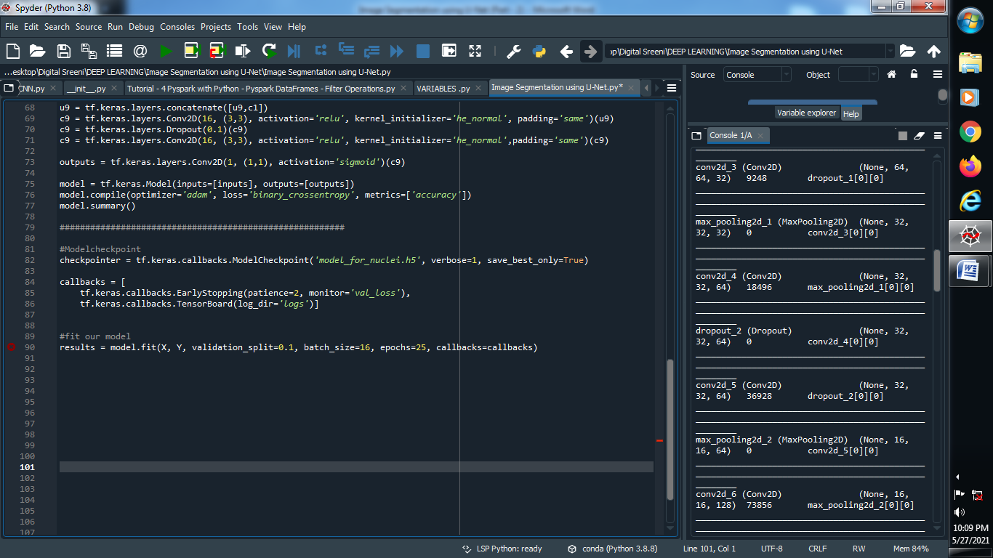

**#########################################################################################**

**→ Understanding the data and getting it ready for U-Net :**